**TECHNICAL TRAINING**

**PROJECT REPORT**

**CREATING AN**

**E-COMMERCE WEBSITE USING HTML AND CSS**



**Submitted To: Submitted by:**

**ROHIT DABAS**

**229071**

**BCA 1ST Year**

**SEC:B**

**CONTENTS**

**1. ACKNOWLEDGEMENT**

**2. WEB DEVELOPMENT CERTIFICATE**

**3. SOURCE CODE**

**4. OUTPUT**

**5. CONCLUSION**

**6. BIBLIOGRAPHY**

**ACKNOWLEDGEMENT**

I would like to express my gratitude to my Web Development teacher Mr. Garvit Verma for his able guidance and support in completing my project.

I would also like to extend my gratitude to The Director sir for providing me with the qualified facility.

Date:

30/11/2022 Garvit Verma

**WEB DEVELOPMENT CERTIFICATE**

This is to certify that **ROHIT DABA**S student of **BCA-B 1st SEM, Roll no:229071** has successfully completed the project work on topic Website designing using HTML & CSS under the guidance of **Mr.Garvit Verma (Technical Trainer)**.

This work is originally done by him. We wish him good future ahead.

Name and Signature of Head of Department:

**Dr. Ankita Sharma**

Name and Signature of Technical Trainer:

**Mr.Garvit Verma**

**SOURCE CODE**

**HTML:**

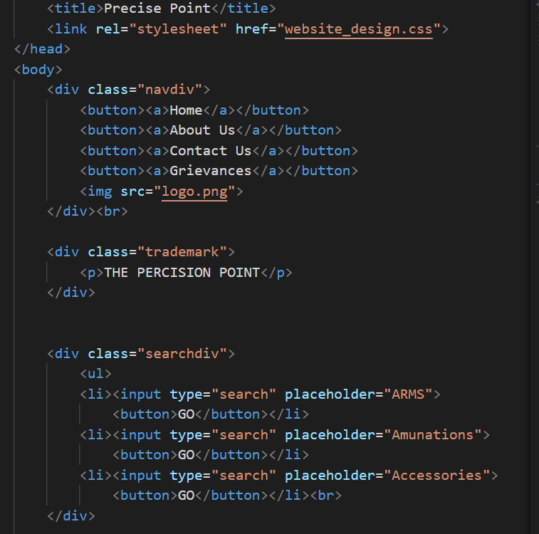

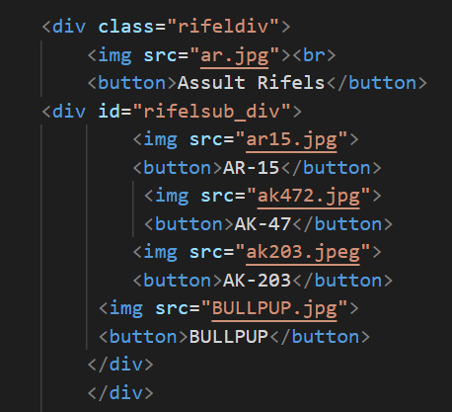

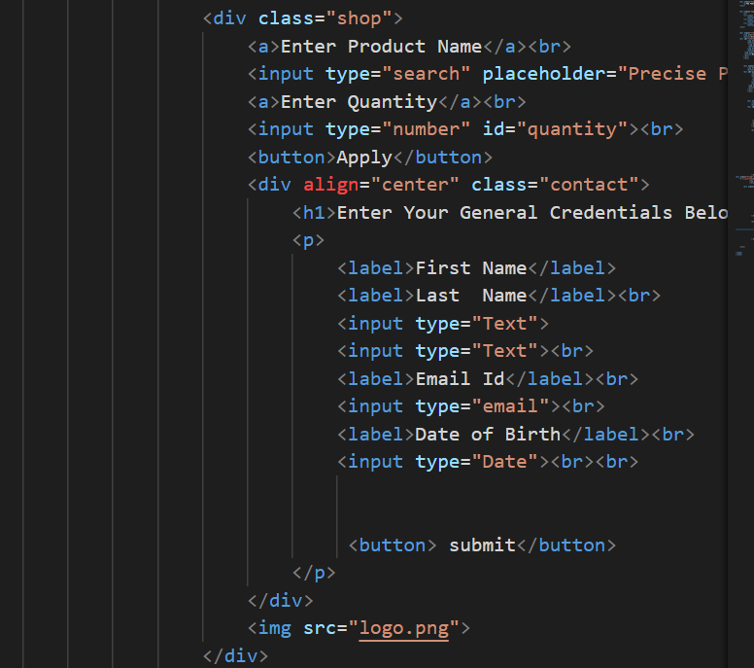

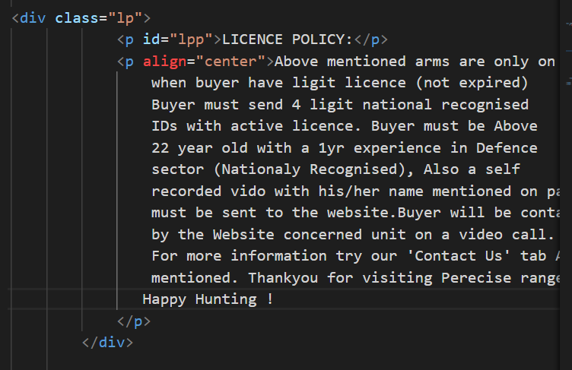

**CSS:**

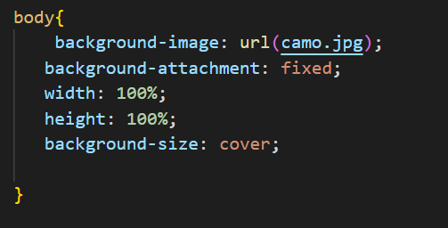

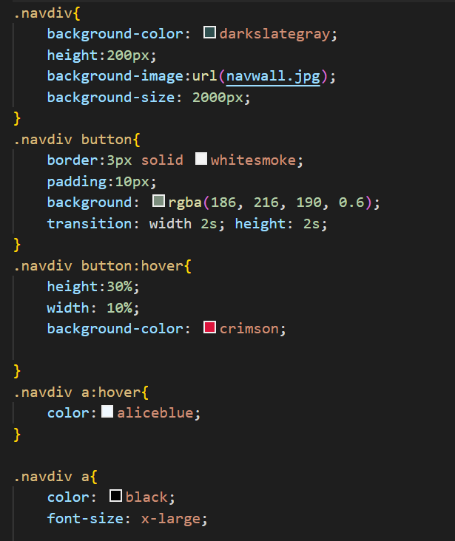

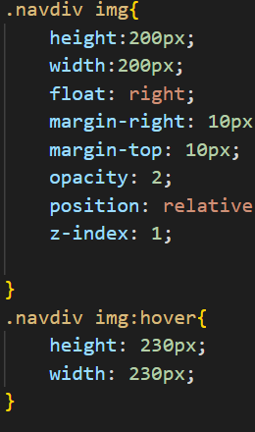

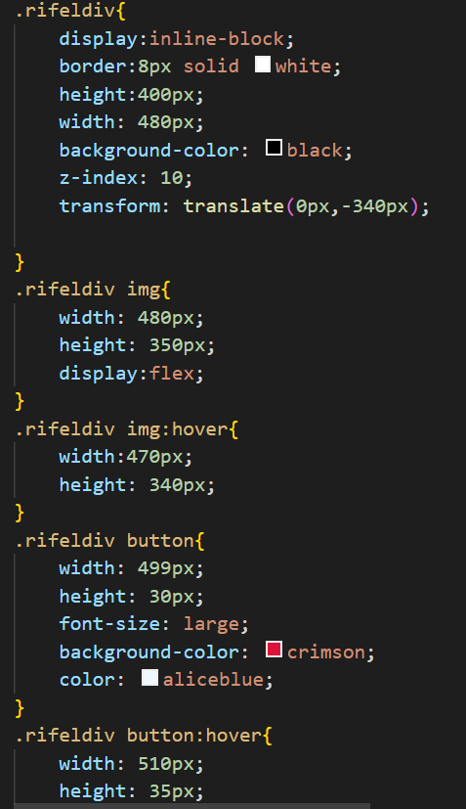

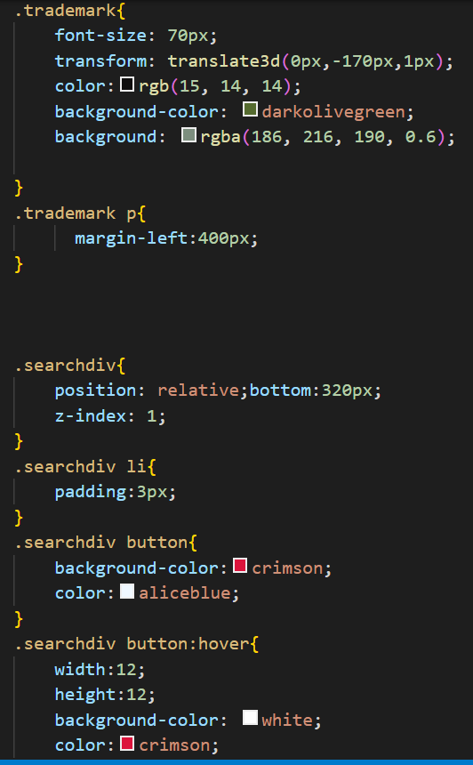

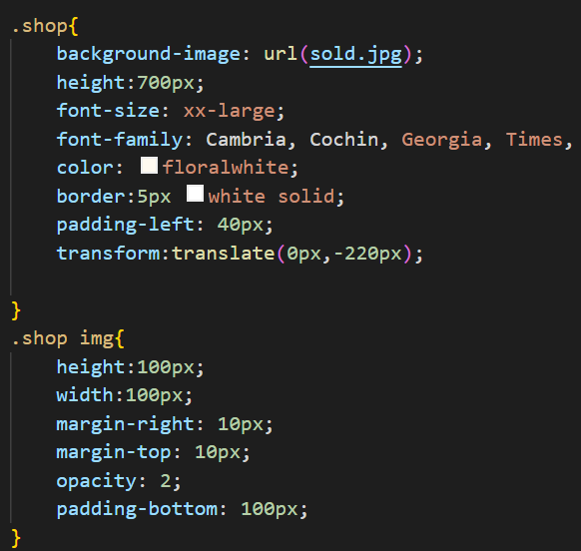

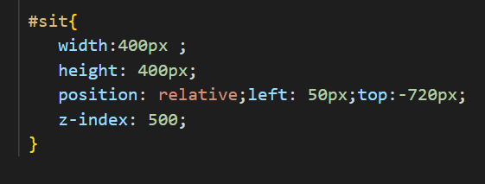

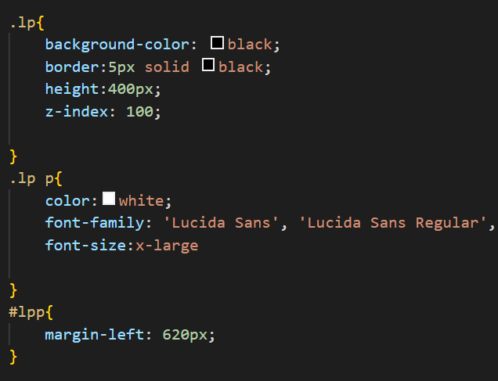



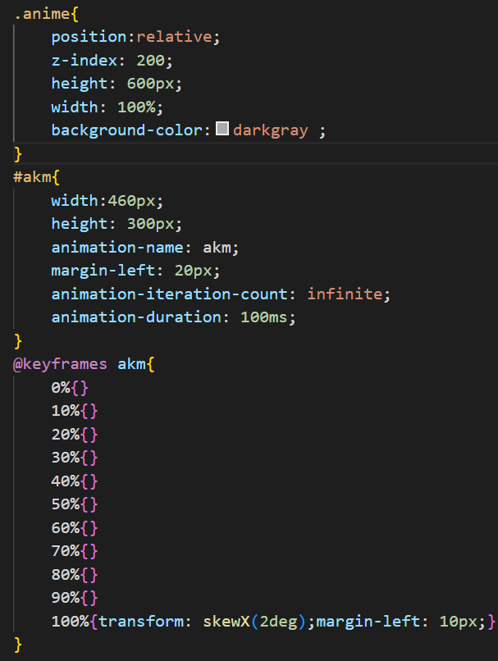

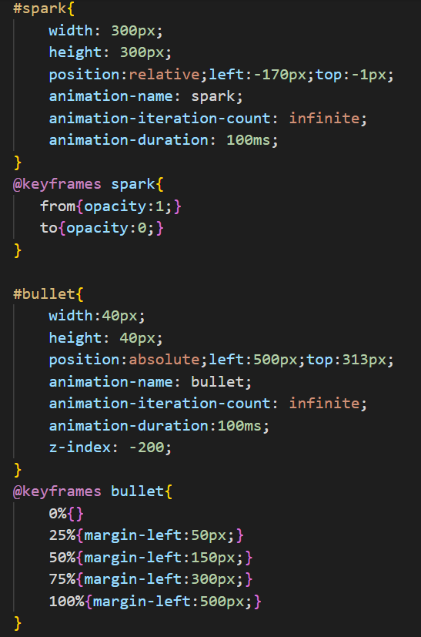

**OUTPUT**

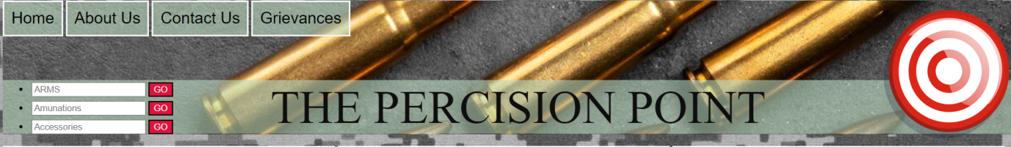

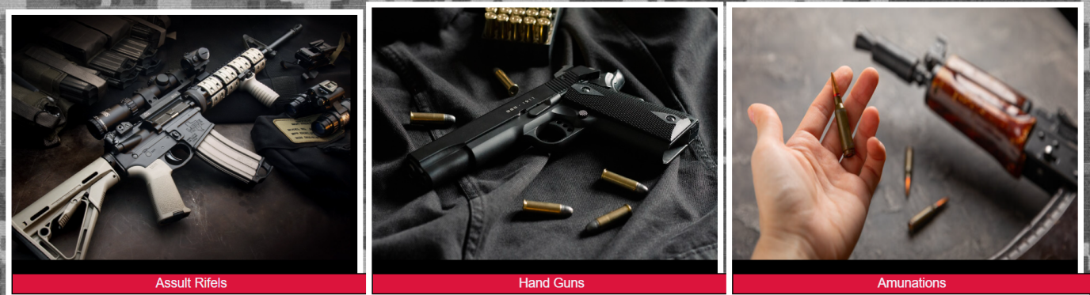

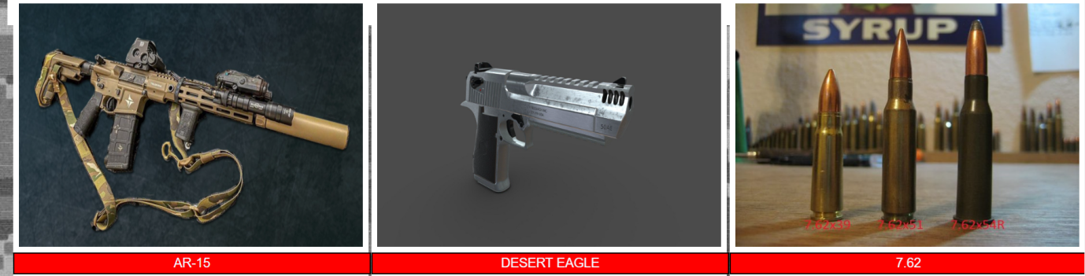

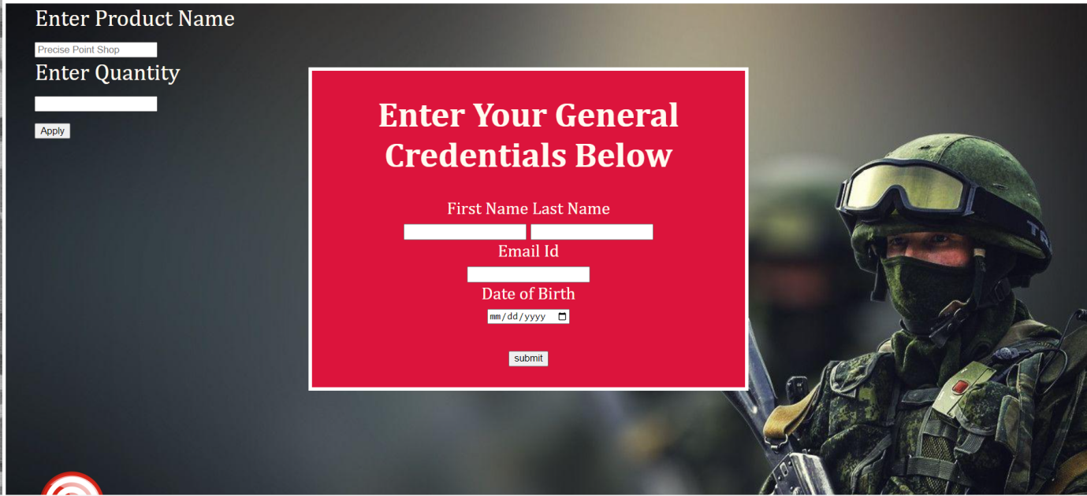

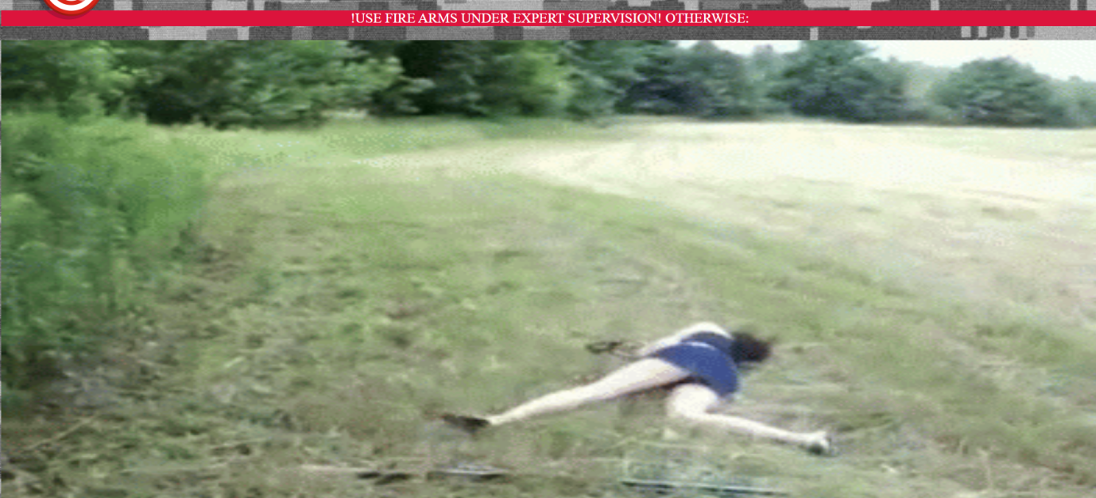





**CONCLUSION**

This project has been a useful experience as I have gained knowledge and new skills for Web Development.

I have completed this project with good impressions and experiences.

**BIBLIOGRAPHY**

**1. [www.w3schools.com](http://www.w3schools.com)**

**2. [www.google.co.in/imghp](http://www.google.co.in/imghp)**

**3. Pait3d(remove bg)**